Network, Protocols and Hardware

Networking and Internet

Networking, also known as computer networking, is the practice of transporting and exchanging data between nodes over a shared medium in an information system. Networking comprises not only the design, construction and use of a network, but also the management, maintenance and operation of the network infrastructure, software and policies.

Example :
- Optical Fiber
- Wireless LANs

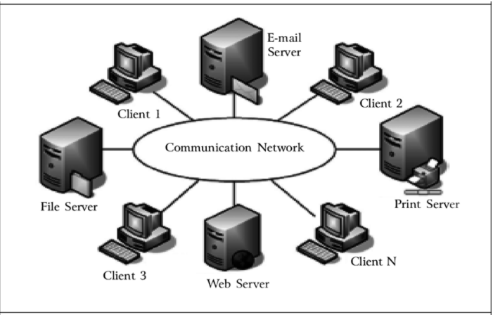

Question
1.Modem ?
2.What is modem ?

Modem is short for "Modulator-Demodulator." It is a hardware component that allows a computer or another device, such as a router or switch, to connect to the Internet. ... Similarly, it converts digital data from a computer or other device into an analog signal that can be sent over standard telephone lines.

How the Web works

- Servers
- Clients
- ISPs
- DNS
- Data centers

Client Server Model
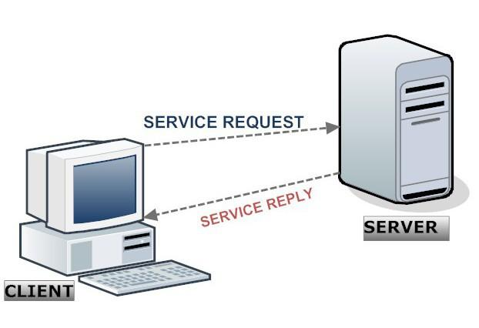
Domain Name Server

- Phone book of the Internet
- Maps domains (www.google.com, www.yahoo.com )to IP addresses (112.123.21.22, 8.8.22.56)
- Humans remember domains
- Computers work with IP

Internet Service Provider

- Company that provides access to user
- Internet can be over DSL, Phone Line, Cable, Fibre, Wireless and other medium

Datacenters
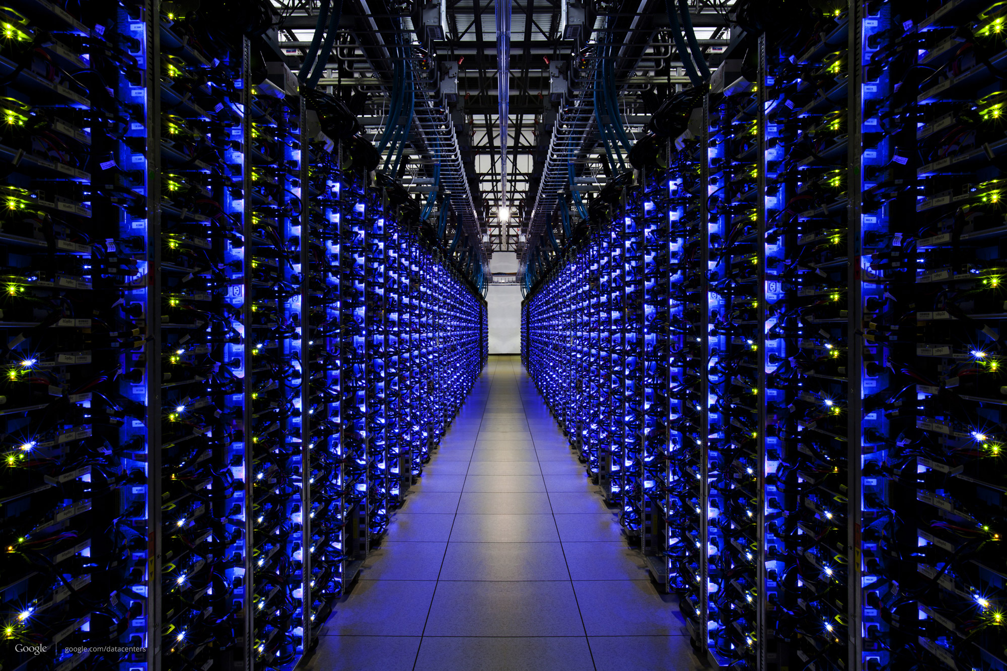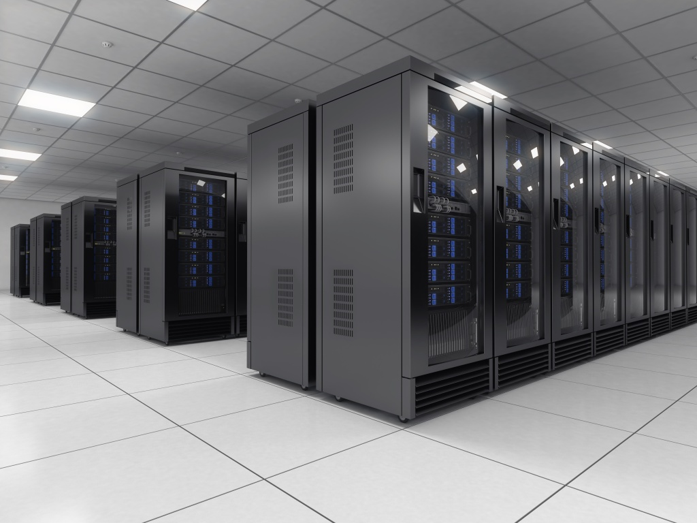

Web terminologies
- Protocols
- Addresses
- Packets

Web Protocols
- TCP/IP
- HTTP
- DHCP
- FTP
- SMTP
- SSH
- Telnet

Web Addresses
- Domain Names
- IP Address
- MAC Address

Domain Names
Human-readable web address
- <subdomain>.<domain>.<TLD>
- TLD – Top level domain
- .org
- .com
- .net
- Country based - .uk, .in,
- Purpose based - .edu, .aero, .info

IP Addresses

- 32-bit, 4-word address (IPv4)
- Uniquely defines a server, a client, a node, or a router.
- IPv6 Address – Default in future - 128-bit (16 octet)
- IP allows –
- Subnets
- Gateways
- Private Ips

Web Addresses
- Domain Names
- IP Address
- MAC Address

Domain Names

Domain names are used in various networking contexts and for application-specific naming and addressing purposes. In general, a domain name identifies a network domain, or it represents an Internet Protocol (IP) resource, such as a personal computer used to access the Internet, a server computer hosting a website, or the web site itself or any other service communicated via the Internet. In 2017, 330.6 million domain names had been registered

IP Address

An IP address is a unique address that identifies a device on the internet or a local network. IP stands for "Internet Protocol," which is the set of rules governing the format of data sent via the internet or local network.

There are 5 classification IP address

MAC Address

A media access control address (MAC address) is a unique identifier assigned to a network interface controller (NIC) for use as a network address in communications within a network segment. This use is common in most IEEE 802 networking technologies, including Ethernet, Wi-Fi, and Bluetooth.

- Media Access Control
- An ID unique to a hardware Network Interface
- Is not dynamic like IP. Is fixed for a hardware device.
- Used by all IEEE 802 Network Technologies

Components of the Web
- Web Pages
- Web Sites
- Web Servers
- Search Engines

Web Page

- A document that can be viewed over web
- Transported over Internet
- Viewed on a browser
- Uses markup (HTML) and styling. Can contain scripts

Web Servers

- A hardware (or software) that hosts the website.
- One website can be spread over multiple servers
- One server can host multiple websites

Web Site

- Collection of webpages
- Also can include other media (audio, images, video)

Web Server Architecture

Client server Architecture

Server HTML
Client or browser

Webpage
- Static
- Dynamic
- Responsive

Communication

IP Address--→Ipv4 -----32 bits It’s Like 192.67.98.07

DNS-Domain name System

client
ISP -Internet Service provider
Server
Req IP Address

